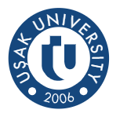
Usak University 3rd International Staff Week
“Re-connection in New Era”
6th June-10th June 2022

Personal Data
Name & Surname
Gender
DOB:
Name of University
Faculty/Department
Working Experience
E-mail
ERASMUS CODE | E10219959
Staff Mobility for Teaching or Training
Area of Interest:
Specify if necessary.
Objectives of the mobility
Added-value of the mobility: | (in the context of the modernisation and internationalization strategies of the institutions involved):
I hereby declare my willingness to participate in the 3rd International Staff Week organized face-to-face by Uşak University.

Signed: Date:

Note: Please submit this duly filled and signed form in pdf.
Upon selection/recommendation, the Mobility Agreement would be shared for further proceeding.

